Joint Inspection Services Committee (JISC) – City of Bridgeport

Overview of JISC: The Joint Inspection Services Committee was established in 2011as an initiative to coordinate efforts of the various inspection services departments/agencies and proactively resolve problem properties identified in Bridgeport. The committee’s goal is to bring about complete and swift compliance of code and ordinance violations to increase the tax base, decrease city operating costs, save city resources, and make neighborhoods cleaner & safer. The committee works to reduce the number of blighted properties, illegal dumping on streets, the amount of illegal/unsafe housing, and the number of unlicensed/illegal businesses.

Inter-department and Agency Collaboration: The Joint Inspection Services Committee consists of the following departments and agencies who meet each Monday at 10am;
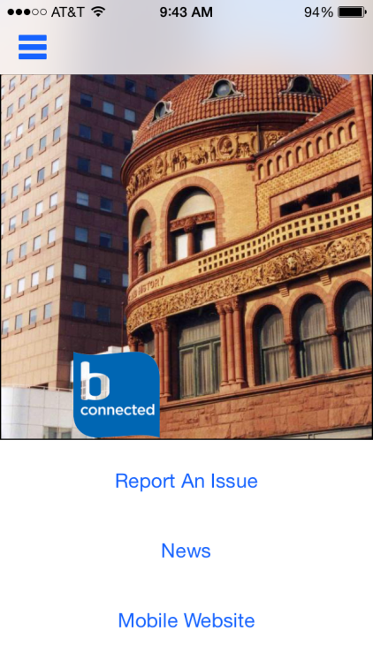
- Fire, Police, City Attorney, Environmental Health, Housing Code Enforcement, Lead Prevention, Zoning Enforcement, Building Code, Anti-Blight and Illegal Dumping, CitiStat/CAO Office, Downtown Special Services District, Bridgeport Housing Authority, United Illuminating, Southern Connecticut Gas Company, and Aquarion Water Company.
JISC Approach:
