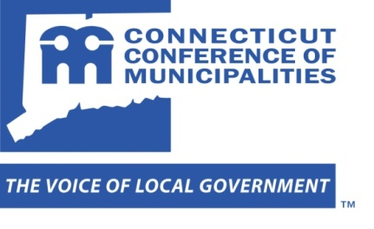

CCM RECOMMENDATIONS FOR CONSIDERATION BY THE
REGIONAL ENTITIES WORKING GROUP
OF THE M.O.R.E. COMMISSION
April 2, 2013

- Encourage the formation of Councils of Government (COGs) in each region.

Empower COGs to:
    - deliver services on a regional basis;
    - negotiate multi-municipal master contracts with municipal employee and teacher unions; and
    - make land use decisions on regionally-significant projects.

- Maintain and increase funding for the Regional Performance Incentive Grant for regional initiatives and start-up funds for RPOs that voluntarily consolidate.

- Increase state nvestment in planning and technical assistance capacity at OPM to assist RPOs and municipalities in collaborative efforts.

★    

If you have any questions, please contact Mike Muszynski (mmuszynski@ccm-ct.org; 203-500-7556) or Ron Thomas (rthomas@ccm-ct.org; 203-430-5537).

